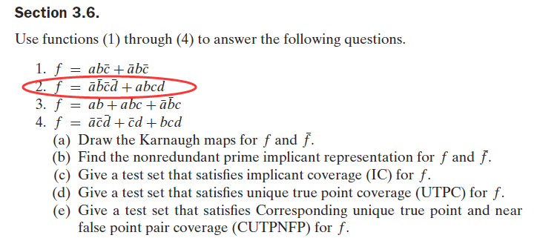

(a) 下图中给出了和的Karnaugh maps , 用1表示，用0表示

**ab**

00 01 11 10

|  |  |  |  |
| --- | --- | --- | --- |
| 1 | 0 | 0 | 0 |
| 0 | 0 | 0 | 0 |
| 0 | 0 | 1 | 0 |
| 0 | 0 | 0 | 0 |

00

01

**cd**

11

10

(b) 



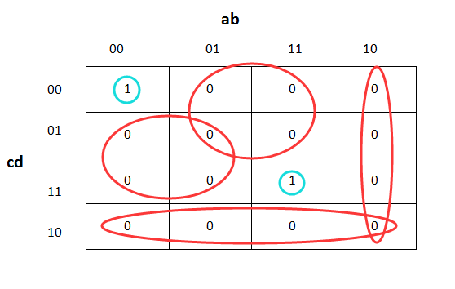

(c) 和总共有6个蕴含：

|  |  |  |  |  |
| --- | --- | --- | --- | --- |
|  | a | b | c | d |
|  | F | F | F | F |
|  | T | T | T | T |
|  | T | F |  |  |
|  | F |  |  | T |
|  |  |  | T | F |
|  |  | T | F |  |

因此IC集合为:T1= {FFFF, TTTT, TFTF, FTFT}

(d) ：{ FFFF }

: {TTTT}

 : {TFTT , TFFT , TFFF}

 : {FTTT , FFTT , FFFT}

: {TTTF , FTTF , FFTF}

: {FTFF , TTFT , TTFF}

下面这张表给出了一个UTPC测试集：

|  |  |  |  |  |
| --- | --- | --- | --- | --- |
|  | a | b | c | d |
|  | F | F | F | F |
|  | T | T | T | T |
|  | T | F | t | t |
|  | F | t | t | T |
|  | t | t | T | F |
|  | f | T | F | f |

UTPC: T2= {FFFF , TTTT , TFTT , FTTT , TTTF , FTFF}